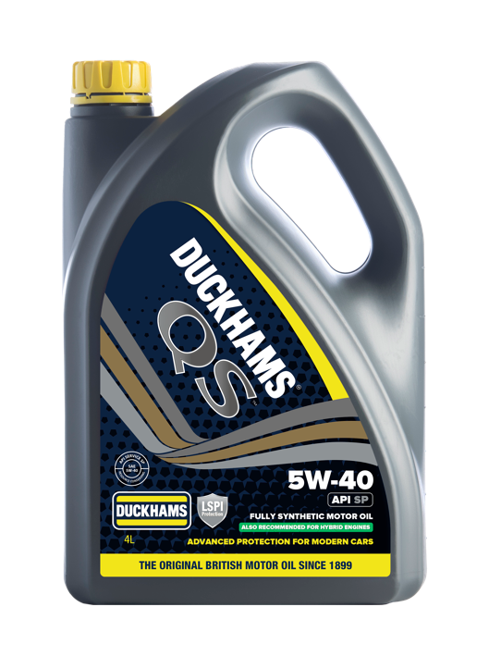
DUCKHAMS QS 5W-40 SP
PRODUCT DESCRIPTION
DUCKHAMS QS 5W-40 SP is a fully synthetic engine oil for use in gasoline and diesel vehicles. Formulated using cutting-edge additive technology and high-quality virgin base oils to meet the requirements of existing vehicles and provide outstanding protection for modern passenger cars.
Duckhams QS 5W-40 SP improves engine efficiency and reduces emissions whilst still ensuring high-temperature protection. Provides improved engine power and fuel economy benefits. Gives excellent engine cleanliness reducing sludge and deposit formation. Provides excellent anti-wear properties, easy cold start and ideal lubrication at elevated temperatures and ensures low oil consumption. It has been designed for Gasoline Direct Injection (GDI) engines to protect them against Low-Speed Pre-Ignition (LSPI).

FEATURES AND BENEFITS
- Reduces internal friction within the engine improving fuel efficiency. Also gives rapid oil circulation at start-up, even in cold conditions, minimising wear, and extending engine life.
- Low volatility base oils, ensures low oil consumption and reduced emissions, minimising environmental impact and running costs.

- Protects engines against Low-Speed Pre-Ignition (LSPI).

- Excellent oxidation stability ensures that the oil offers outstanding protection throughout the oil drain interval.
- Unsurpassed deposits and sludges reduction maintains engine efficiency and counteracts hydrolysis.

- Excellent soot handling properties reduces timing chain wear, maintaining engine performance and efficiency.

SPECIFICATIONS AND APPROVALS
Is approved for use where the following specification is required:
API SP
Meets or exceeds the required performance level for:
API SN, SM, SL

TYPICAL PHYSICAL CHARACTERISTICS
Property | Unit | Typical Data
Viscosity Grade | - | 5W-40
Viscosity @ 100 °C | cSt | 13.31
Viscosity @ 40 °C | cSt | 81.23
Viscosity Index | - | 166
CCS @ -35 °C | cP | 6096
Flash Point (Closed Cup) | °C | 228
Pour Point | °C | -36
Total Base Number | mgKOH/g | 7.4
Density @ 15 °C | Kg/L | 0.851

Typical physical characteristics are provided as an indication of properties based on current production data only, and should not be construed as a specification. Acceptable variation may occur during the manufacturing process without affecting the performance of the lubricant. This data can change without notification. Current version of this data supersedes all previous versions.

HEALTH, SAFETY AND ENVIRONMENT
Based on available information this product is not expected to present a significant health and safety hazard when used in the recommended applications and in accordance with the recommendations in the Safety Data Sheet. Safety Data Sheet available on request through your sales agent, or from the internet. Avoid prolonged or repeated contact with engine oils. Wash skin thoroughly after contact.
Protect the environment. Dispose of product and packaging in accordance with local regulations.

STORAGE AND HANDLING
Packed lubricants should be stored under cover. Where outside storage of drums is unavoidable, they should be laid horizontal to avoid water ingress. Product should not be stored in direct sunlight or excessively high, or low, temperatures. Duckhams can provide professional advice on the storage of lubricants.

